LAB 3 – CREATE DATA LAKE GEN – II STORAGE ACCOUNT

1. Deployment

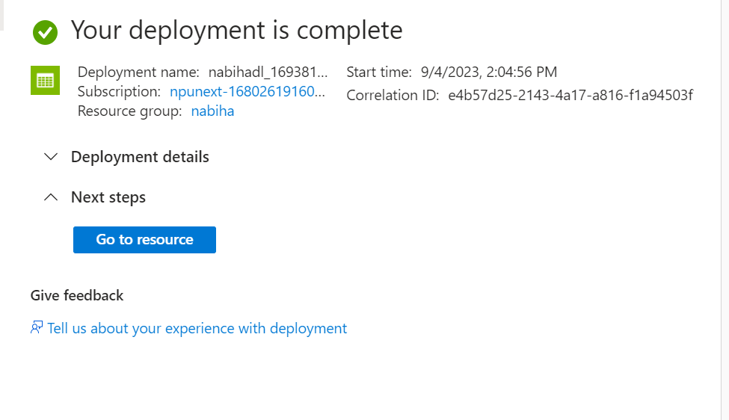

1. Checking Resource

